OBSERVATION1

Selected Date as 10 april while filling ledger entry form, but it is displaying 9 April when viewing ledger entries.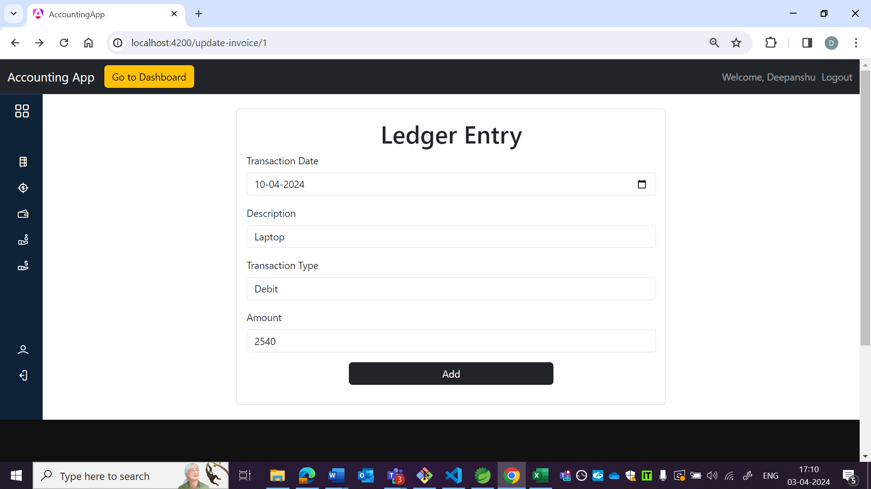

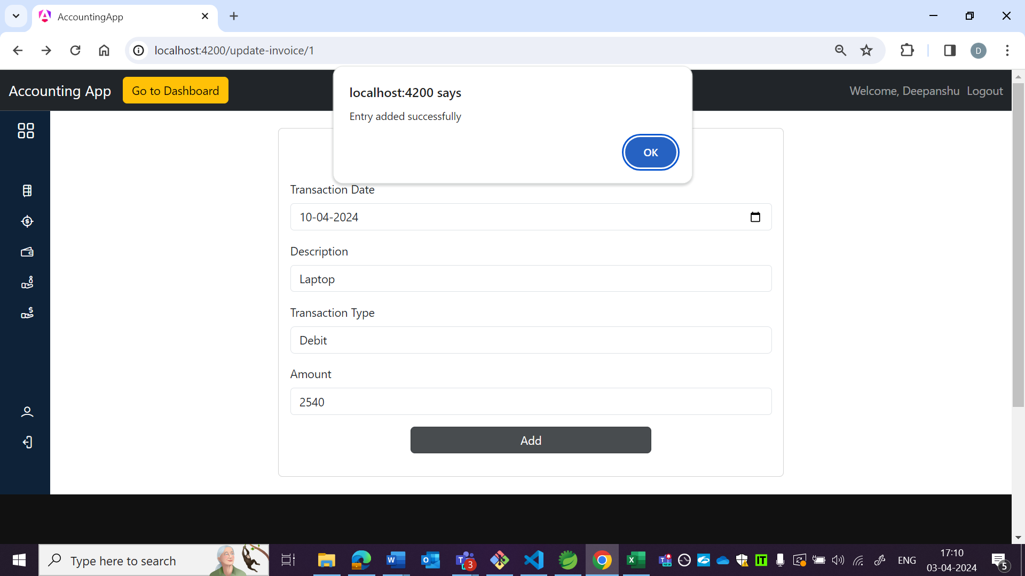

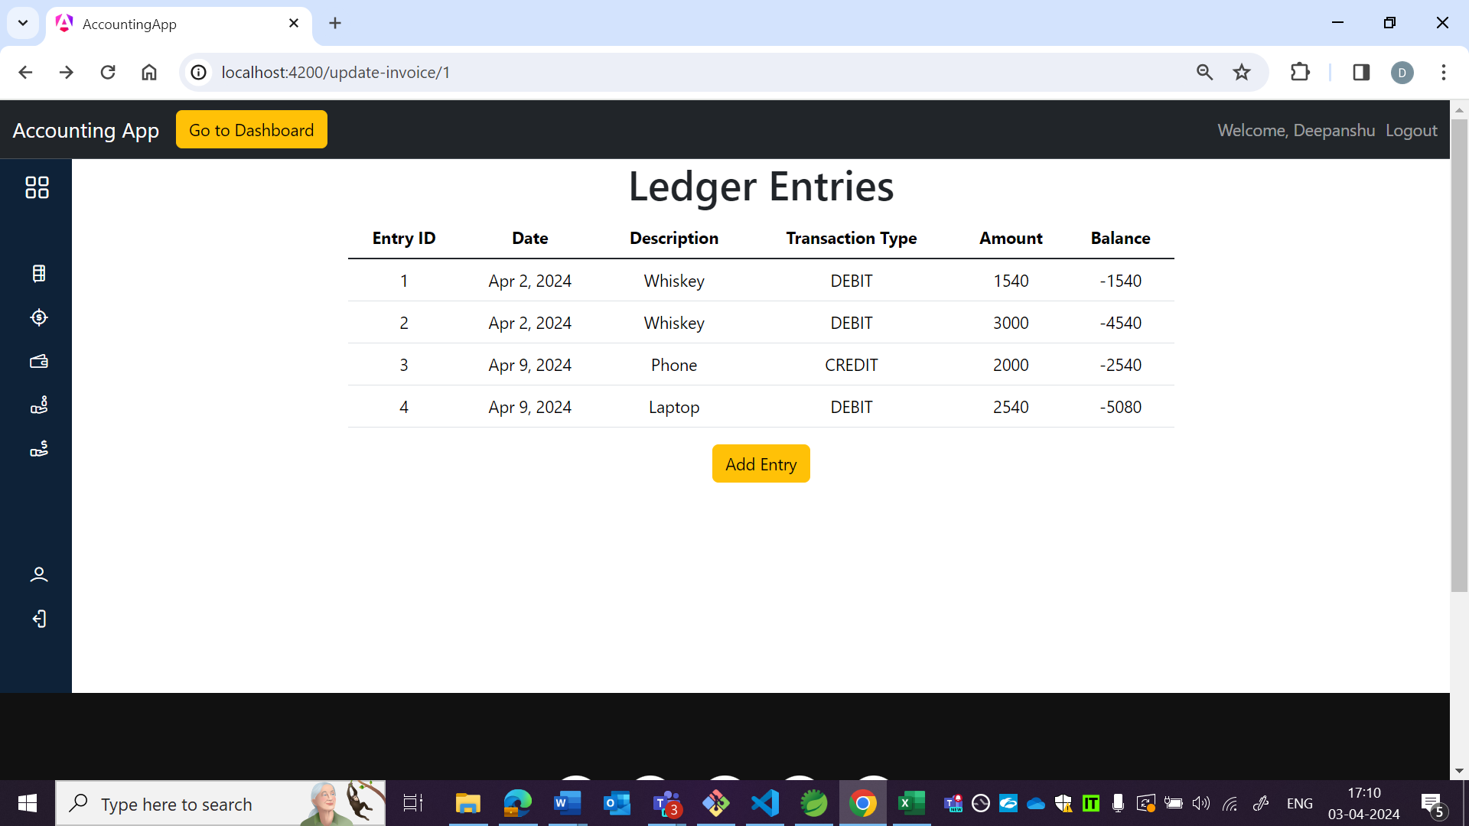

OBSERVATION2:

As per US entry id field should not be displayed.

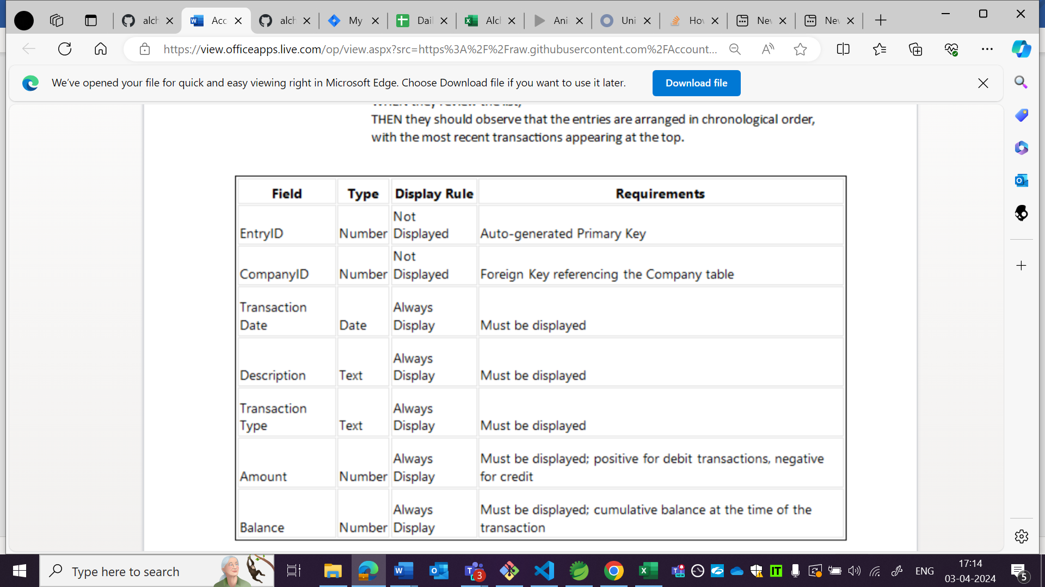

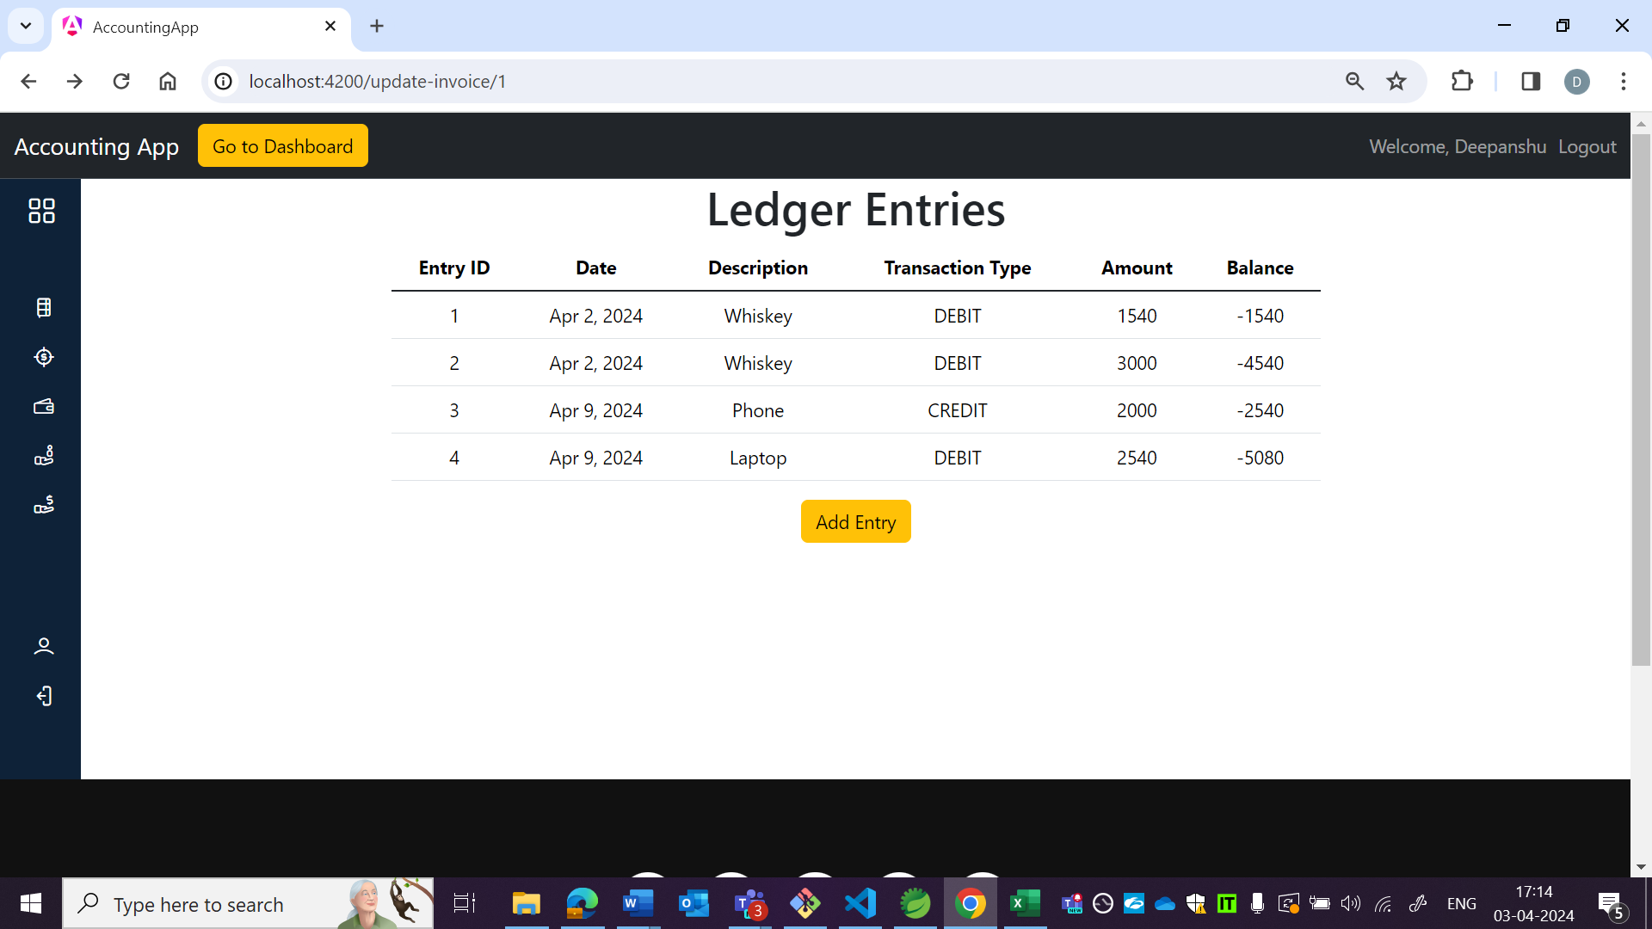

OBSERVATION3:

As per US latest entry should be displayed at top but it is showing at bottom.

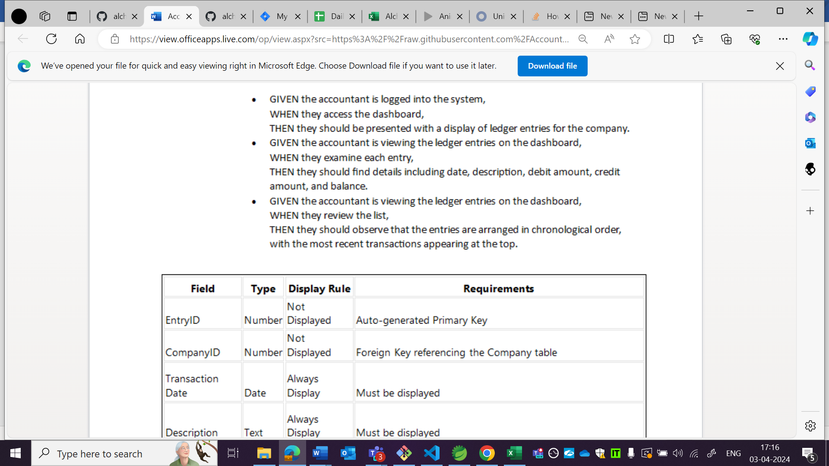

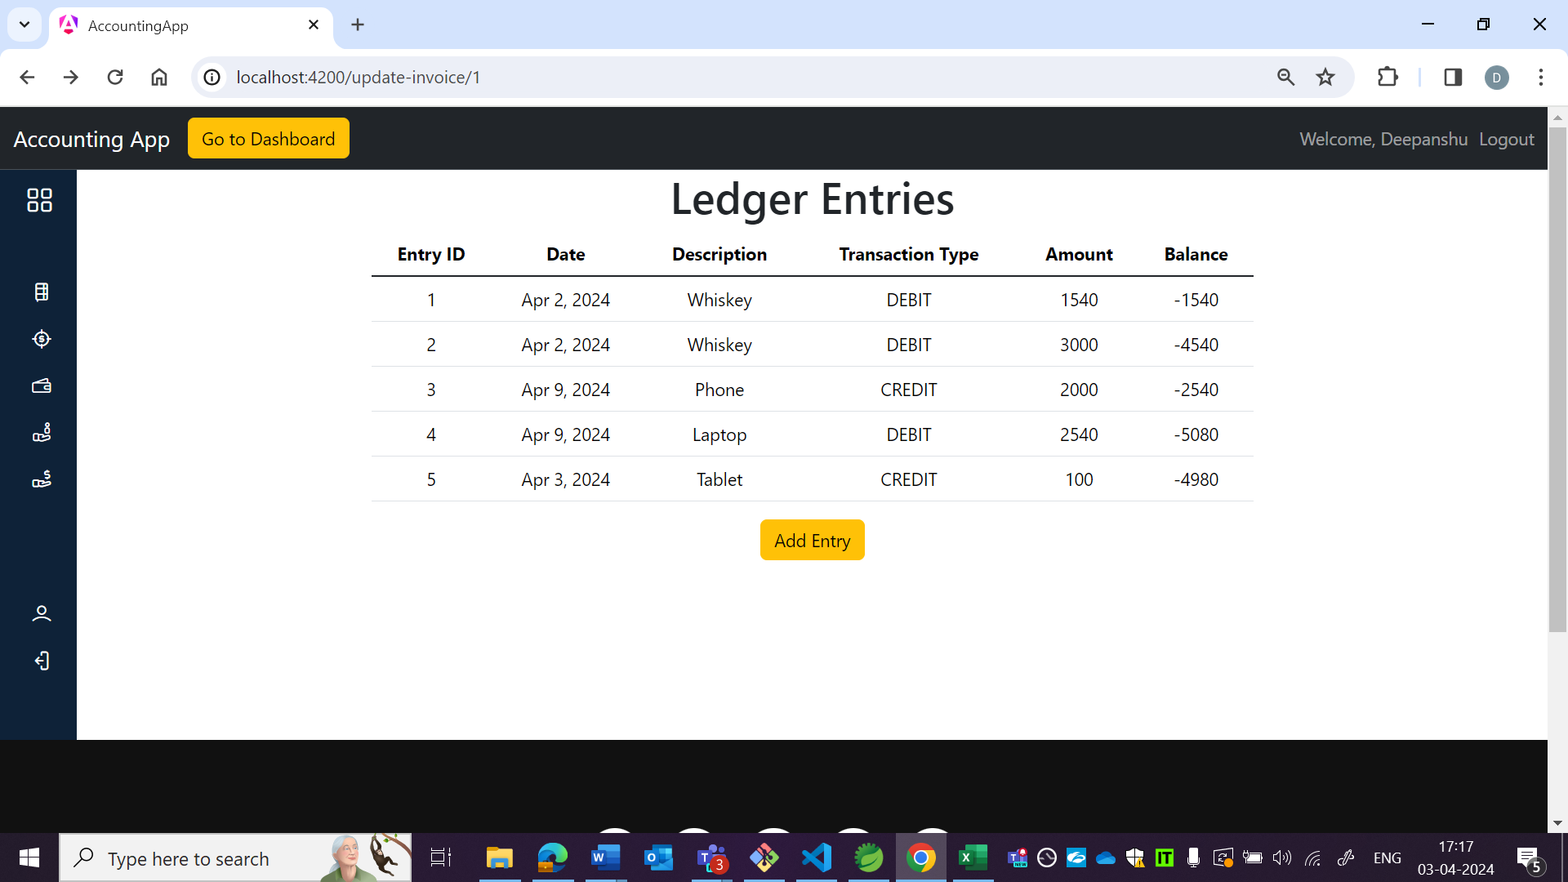

OBSERVATION4:

It is accepting future date when adding new ledger entry.

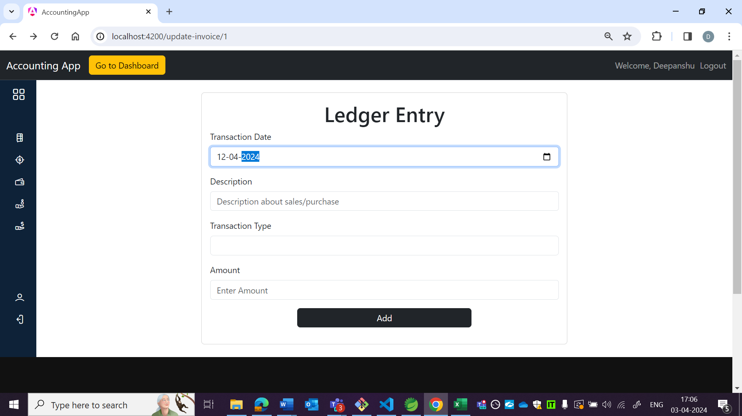

OBSERVATION5:

Balance field is there in wireframe but in app, although it is correct as per behaviour table in US.

App: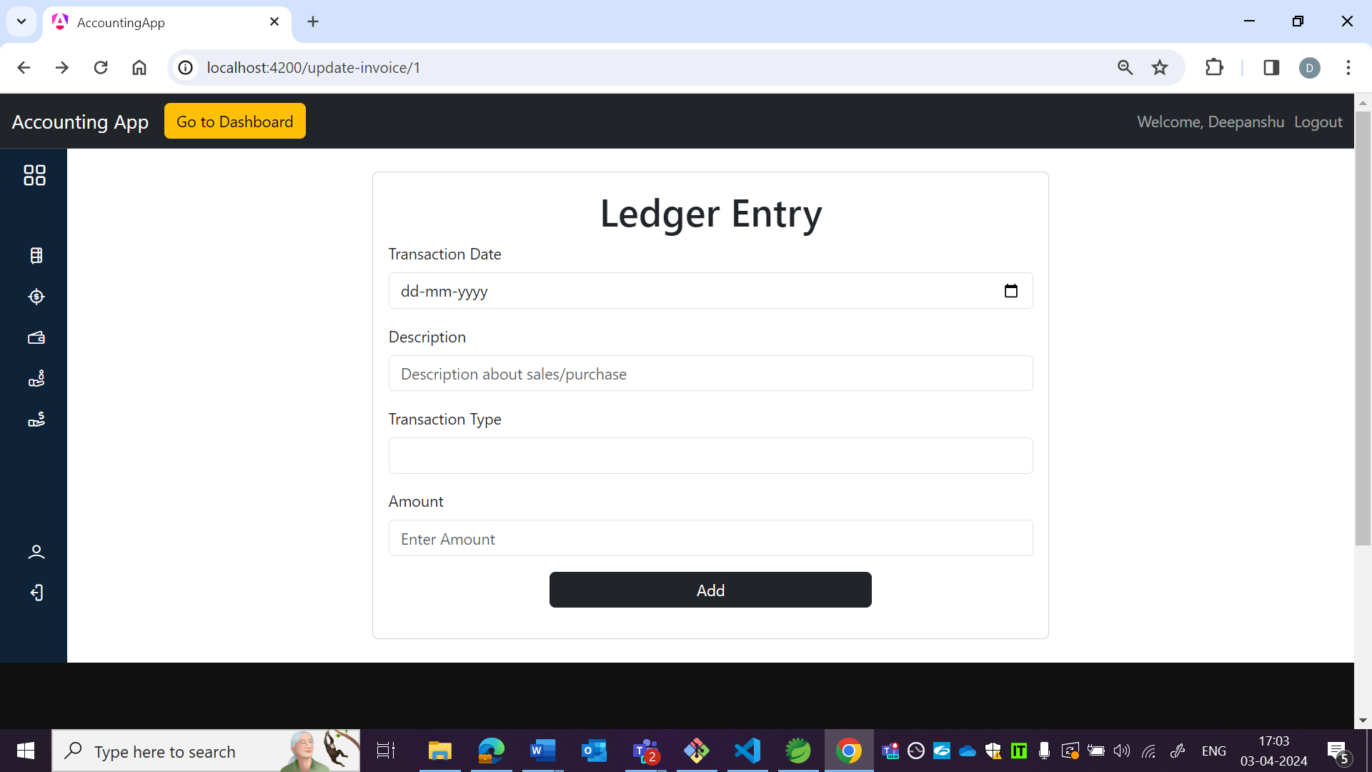

Wireframe:

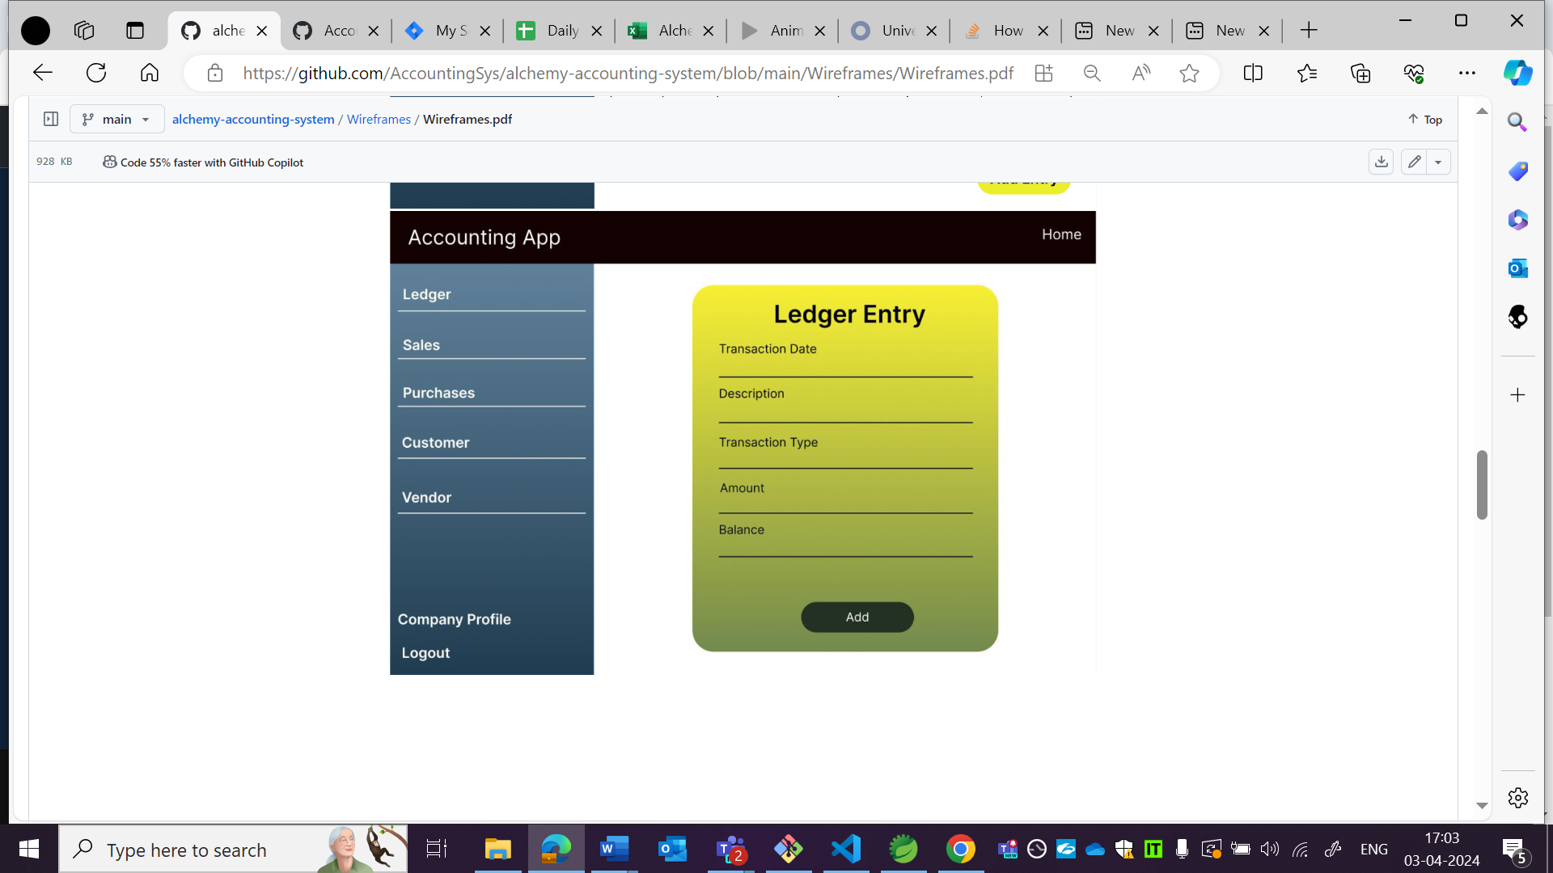

OBSERVATION6:

Background colour is different.

App:

Wireframe:



OBSERVATION7:

Page name is not matching as per wireframe and as per wireframe content should be in tabular format.

